*Florida International University*

*School of Computing and Information Sciences*

CIS 4911 - Senior Capstone Project

Software Engineering Focus

Feature Document

User Story #664

**Team Member:**

Andrew Mitchell

**Product Owner(s)**:

Francisco R. Ortega

**Mentor(s)**:

Francisco R. Ortega

...

**Instructor**: Masoud Sadjadi

**User Story** Implement Save Image Transparency

* As a User I would like to save an Image with a Transparent Background so I can have more diversity on which surfaces I can put my images on.

Acceptance Criteria

* When the user saves, the background must save transparent (unless colored over).

**Use Case** Save Image

Use Case

Enables saved images to preserve alpha coloring.

Details:

Actor: User

Pre-conditions:

Leap motion must be running (or have a keyboard to call the save function).

Description:

Use case begins when the user saves the file by using the leap motion (proximity menu or leap keyboard touch gesture). The image will then save to the computer.

Post-conditions:

Any saved files can be opened with the images alpha color intact (including transparent backgrounds).

Decision Support:

Frequency: Low. The user may only save files every once in a while.

Criticality: High. The product owner wants the user to have control over whether the user wants a transparent background or not. Alpha preservation is also important in the future when we have a ‘load image’ functionality.

Risk: Low. There will be some research required into how libcinder saves files (as well as what image type preserves alpha), but it should not provide much trouble.

Reliability: Highly.

Mean time to Failure – Almost never. It should only fail with hardware failure (hard drive cannot write to disk, etc).

Availability –Available when leapgestures are enabled (save function works).

Performance:

N/a

Supportability:

Leap motion device

Modification History:

Owner: Andrew Mitchell

Initiation date: 3/22/2016

Date last modified: 4/3/2016

**Use Case Diagram**

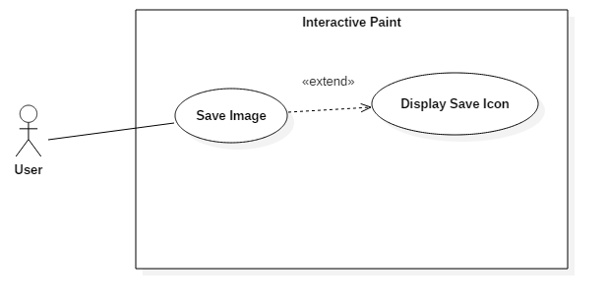

**Sequence Diagram**

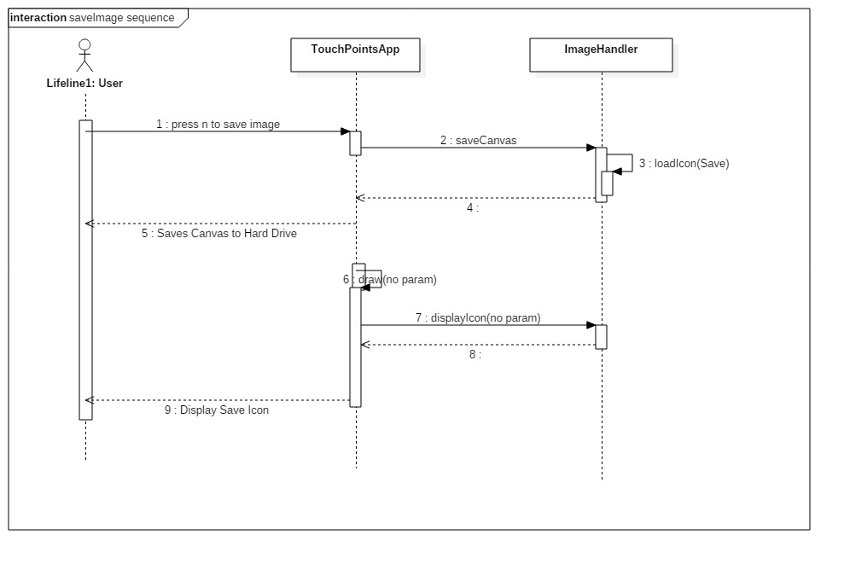

**Class Diagram**

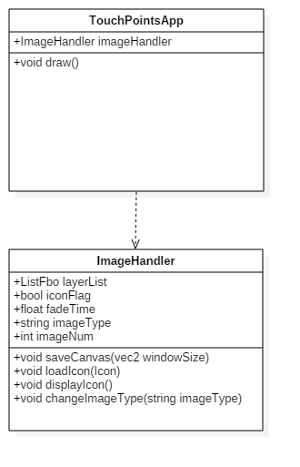

**Unit Test**

Sunny Day:

Test Case: Save Transparent Image

Test Purpose:

Ensure alpha preservation on save.

Test Setup:

1. Draw large filled Green Square to cover half the screen.
2. Draw a Filled Red Circle.
3. Press the alpha reduce button
4. Draw a filled Red Circle in a new location
5. Repeat step 3 through 4, about 3 to 4 times.
6. Press ‘n’ to save the image.
7. Open the image in sketchbook
8. Change background color to blue.

Test Output:

Opening the image in sketchbook appeared with a white background.

Altering the ‘background’ in sketchbook changed the background of all areas that were not drawn in.

Expected Output:

Any area in the picture not drawn on should appear ‘white’ in the thumbnail and when opened with Sketchbook.

After changing the background color in sketchbook, any area that was not drawn on should be blue by the end of the test.

Rainy Day Tests:

N/a

**Integration Test**

Currently working with all of our draw and layer functionality. Including leap motion drawing as well as multitouch drawing.

Drawing on any layer still gets saved. Changing the layers alpha values and saving also preserves each layers individual alpha values (on top of the ‘brush’ alpha value it had when the drawing occurred).

**User Guide**

Use the leap motion keyboard tap gesture to save a file, if you have keyboard functionality you can also use the ‘n’ key to save a file. Open the file in a program which preserves alpha coloring to see your new drawing (with alpha preservations)! You can view example images below.

This image shows a direct print screen of our drawing inside Interactive Paint

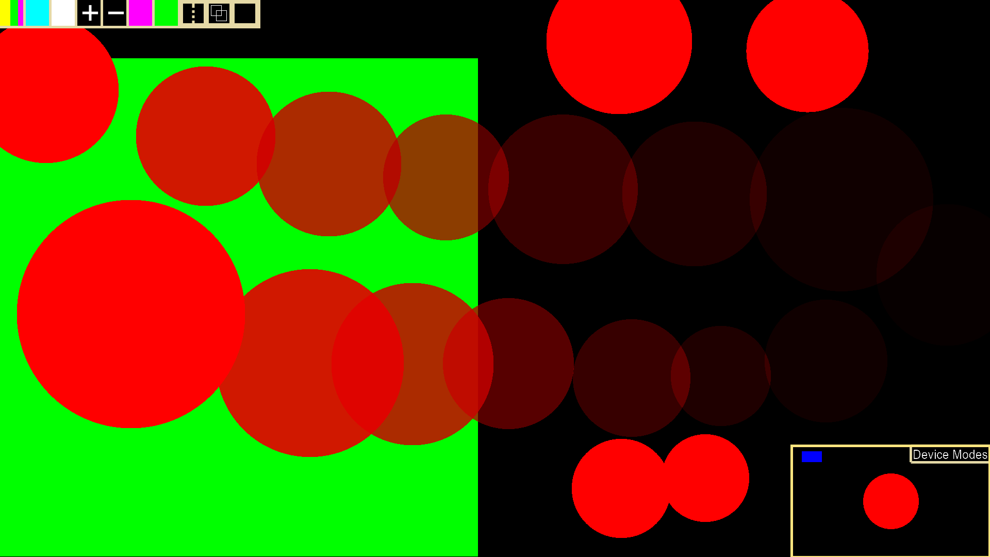

After saving the file we opened in in sketchbook and see that the background was ‘transparent’ and is drawn in as white by default in the program we use ‘Sketchbook’ (which preserves alpha).

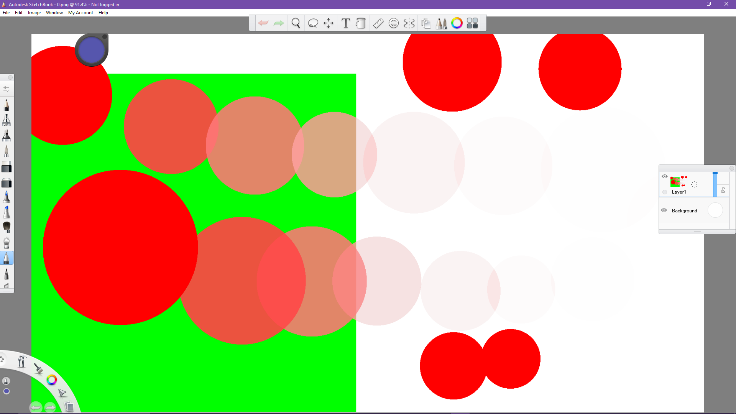

We can alter the background color to blue in Sketchbook and see that the image successfully alters Sketchbooks background color!

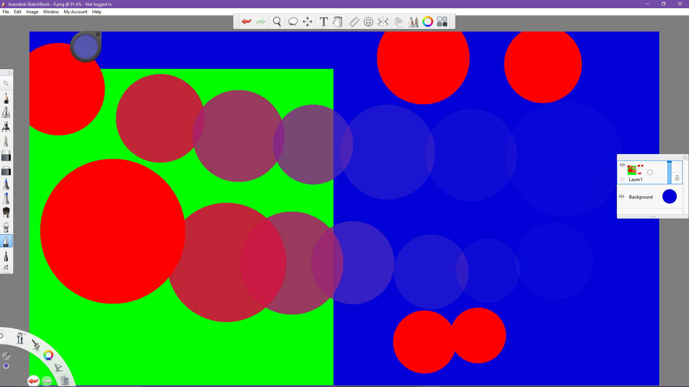

**Glossary**

Alpha Color – A fourth color (in addition to r,g,b) which controls ‘transparency’